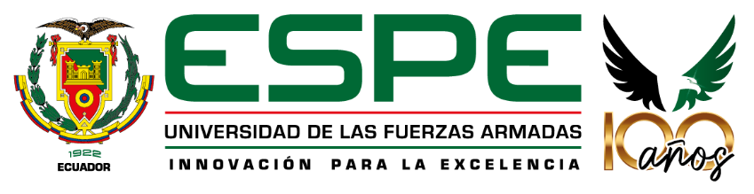

Universidad de las Fuerzas Armadas - ESPE
Object Oriented Programming

NRC: 30812

Ing. Jorge Edison Lascano, PhD

App for First-Time Mothers

Members:
Nase Solorzano Jennyfer Nicole
Ñacato Toapanta Angie Nicole
Palomo Otto Cristian David

- Problem Statement
Globally, the postpartum period is identified by the World Health Organization (World Health Organization: WHO, 2022) as a critical stage of vulnerability. It is estimated that a lack of adequate guidance during the first weeks of a newborn's life increases complications from poor hygiene and feeding practices by 25%. The lack of educational support networks for new mothers is a global phenomenon that affects neonatal health and maternal emotional well-being.

In Ecuador, public health policies primarily focus on prenatal checkups and the delivery process. However, there is a significant gap in the fourth trimester or postpartum education. Statistics from the Ministry of Public Health (MSP) indicate that while breastfeeding initiation is high, exclusive breastfeeding rates drop significantly within the first three months. This decline is often attributed to the lack of technical guidance for first-time mothers, who frequently resort to traditional myths or unverified digital information, leading to nutritional deficiencies or health complications for the infant.

At Calderon General Teaching Hospital a recurring pattern has been observed among first-time mothers. Clinical records and preliminary observations show that a high percentage of pediatric emergency visits are related to non-pathological issues such as infant colic, skin irritations due to poor hygiene, and lactation crises. These situations are directly linked to the mothers' lack of experience and the absence of a formal orientation program. This educational void not only saturates emergency services but also diminishes the mother's confidence in her caregiving abilities.

1.1. Problem Formulation
To what extent would the implementation of a comprehensive orientation and support program improve neonatal care practices and reduce maternal stress levels among first-time mothers at Calderon General Teaching Hospital?

1.2. Research Objectives
General Objective:
- To identify the current level of knowledge and the most frequent fears regarding newborn care breastfeeding, hygiene, and sleep among first-time mothers in the community.
- To define the theoretical and pedagogical foundations necessary for an effective maternal-infant support program based on current health standards.
- To develop a practical guide and a series of educational workshops focused on evidence-based techniques for infant care and maternal self-care.
- To evaluate the feasibility and perceived impact of the proposed program through a pilot group of participants.

1.3. Justification
This research addresses the critical lack of educational support faced by first-time mothers after hospital discharge, a gap that significantly increases maternal stress and unnecessary visits to pediatric emergency departments due to poorly executed basic care. The project is technically and socially justified by proposing a comprehensive guidance program that not only seeks to reduce neonatal morbidity through validated breastfeeding and hygiene practices, but also to optimize local healthcare resources by empowering mothers in their role. Through a precise diagnosis and a structured methodological approach, this research aims to transform the uncertainty of a first pregnancy into an informed, safe, and emotionally stable motherhood.

World Health Organization: WHO. (2022, 30 marzo). La OMS insta a ofrecer atención de calidad a las mujeres y los recién nacidos en las primeras semanas cruciales después del parto. Organización Mundial de la Salud. https://www.who.int/es/news/item/30-03-2022-who-urges-quality-care-for-women-and-newborns-in-critical-first-weeks-after-childbirth

